**Jewish Festival**

**What are the main Jewish festivals?**

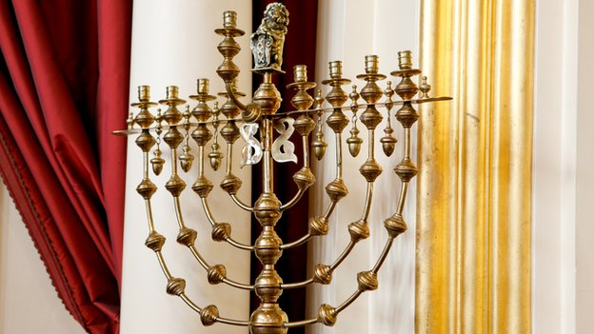Branched candlesticks are used during Hanukkah

**As well as annual festivals, observant Jews keep a holy day each week, called**[**the Sabbath or Shabbat**](http://www.bbc.co.uk/religion/religions/judaism/holydays/sabbath.shtml)**, which occurs on Saturday. Work is forbidden on the Sabbath as well as on some Jewish holidays.**

Jewish holidays are celebrated on fixed dates in the lunar Jewish calendar, but this calendar varies in relation to the solar calendar used in the west. This means that the holidays move around with relation to western dates.

The Jewish calendar occasionally includes an extra month to keep it synchronised with the solar year, and sometimes days are moved around to make sure that the Sabbath does not coincide with certain festivals.

Outside Israel, Jewish festivals sometimes last one day longer. This has an historical basis in the difficulties faced accurately determining the Jewish calendar based on the lunar cycle. Jews living outside Israel being unsure of a festival's exact date would celebrate for an extra day. Although dates can be calculated accurately now, many non-Israeli Jews still follow this practice.

The Jewish day begins at sunset, which means that all Jewish holidays begin the evening *before* their western date.

**Rosh Hashanah (1-2 Tishri)**

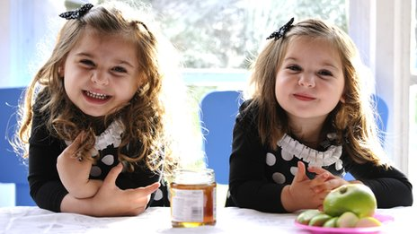Jews eat apples dipped in honey to symbolise hope for a sweet new year

[**Rosh Hashanah**](http://www.bbc.co.uk/religion/religions/judaism/holydays/roshhashanah.shtml) is the Jewish New Year, when Jews believe God decides what will happen in the year ahead. The synagogue services for this festival emphasise God's kingship and include the blowing of the shofar, a ram's horn trumpet.

This is also God's time for judgement. Jews believe God balances a person's good deeds over the last year against their bad deeds and decides their fate accordingly.

The 10 days beginning with Rosh Hashanah are known as the [**Days of Awe**](http://www.bbc.co.uk/religion/religions/judaism/holydays/awe.shtml), during which Jews are expected to find all the people they have hurt during the previous year and apologise to them. They have until Yom Kippur to do this.

**Yom Kippur, the Day of Atonement (10 Tishri)**

The Day of Atonement is regarded as a sacred and solemn occasion, on which synagogue attendance is particularly important. On [**Yom Kippur**](http://www.bbc.co.uk/religion/religions/judaism/holydays/yomkippur.shtml)Jews believe God makes the final decision on who will live, die, prosper and fail during the next year, and seals his judgement in the Book of Life.

It is a day of fasting. Worship includes the confession of sins and asking for forgiveness, which is done aloud by the entire congregation.

**Sukkot, the Feast of Tabernacles (15-21 Tishri)**

The book of Exodus tells the story of the Israelites' journey to the promised land. [**Sukkot**](http://www.bbc.co.uk/religion/religions/judaism/holydays/sukkot_1.shtml) commemorates these years spent wandering the desert, living in makeshift dwellings.

For the duration of the festival Jewish families live in temporary huts called sukkot (singular: sukkah) that they build out of branches and leaves.

Each day they hold celebrations with four types of plant: branches of palm, myrtle and willow and a citrus fruit called an etrog. Sukkot is intended to be a joyful festival that lets Jews live close to nature and know that God is taking care of them.

**Shemini Atzeret and Simchat Torah (22 Tishri; outside Israel Simchat Torah is 23 Tishri)**

Shemini Atzeret is an extra day after the end of Sukkot. Jews spend some time in their sukkah, but not as much, and without some of the rituals.

Simchat Torah means "Rejoicing in the Torah". Synagogues read from the Torah every week, completing one read-through each year. They reach the end on Simchat Torah and this holiday marks the completion of the cycle, to begin again the next week with Genesis.

**Hanukkah, or Chanukah (25 Kislev - 2 or 3 Tevet, depending on the length of Kislev)**

The story of [**Hanukkah**](http://www.bbc.co.uk/religion/religions/judaism/holydays/hanukkah.shtml) is that of the "miracle of the oil". In 164 BC a group of Jews called the Maccabees recaptured Jerusalem from the occupying Syrian Greeks. When they came to rededicate the temple, they had only enough sacred oil to light the menorah (seven-branched candlestick) for one day.

It is said that the candles stayed lit for eight days despite this. During the eight days of Hanukkah, Jews light one extra candle on a special nine-branched menorah, called chanukkiya, each night.

They say prayers and eat fried foods to remind them of the oil. Some gifts are exchanged, including chocolate money and special spinning tops called dreidels.

**Tu B'Shevat (15 Shevat)**

[**Tu B'Shevat**](http://www.bbc.co.uk/religion/religions/judaism/holydays/tubishvat.shtml) is the Jewish New Year for Trees. The Torah forbids Jews to eat the fruit of new trees for three years after they are planted. The fourth year's fruit was to be tithed to the Temple.

Tu B'Shevat was counted as the birthday for all trees for tithing purposes, like the beginning of a fiscal year. On Tu B'Shevat Jews often eat fruits associated with the Holy Land, especially the seven plants mentioned in the Torah: wheat, barley, grapes, figs, pomegranates, olives and dates. Planting trees is another tradition.

**Purim (14 Adar)**

[**Purim**](http://www.bbc.co.uk/religion/religions/judaism/holydays/purim_1.shtml) celebrates the events told in the Book of Esther, in which a wicked Persian nobleman named Haman plotted to murder all the Jews in the land.

The Jewish heroine Esther, wife of the king Ahasuerus, persuaded her husband to prevent the massacre and execute Haman. Because Esther fasted before going to the king, Purim is preceded by a fast. On Purim itself, however, Jews are commanded to eat, drink a lot and celebrate.

Almsgiving is also a very important Purim tradition. The Book of Esther is read in the synagogue and the congregation use rattles, cymbals and boos to drown out Haman's name whenever it appears.

**Passover, or Pesach (15-21 Nissan)**

This is one of the most important Jewish festivals. During [**Passover**](http://www.bbc.co.uk/religion/religions/judaism/holydays/passover_1.shtml), Jews remember the story of the Israelites liberation from slavery in Egypt.

God unleashed ten plagues on the Egyptians, culminating in the death of every family's eldest son. God told the Israelites to sacrifice lambs and mark their doors with the blood to escape this fate. They ate the lambs with bitter herbs and unleavened bread (unrisen bread without yeast).

These form three of the components of the family meal, called the seder, eaten by Jews on the first two nights of Passover.

There are blessings, songs and other ingredients to symbolise parts of the story. During the meal the adults explain the symbolism to the children.

**Shavuot (6 Sivan)**

[**Shavuot**](http://www.bbc.co.uk/religion/religions/judaism/holydays/shavuot.shtml), or the festival of Weeks, is a harvest festival. Historically, at this time of year the first fruits of the harvest were brought to the temples.

Shavuot also marks the time that the Jews were [**given the Torah on Mount Sinai**](http://www.bbc.co.uk/religion/religions/judaism/history/secondcovenant.shtml).

Shavuot is marked by prayers of thanks for the Holy Book and study of its scriptures. Customs include decorating synagogues with flowers and eating dairy foods.

**Tisha B'Av (9 Av)**

This is a day of commemoration for a series of tragedies that have befallen the Jewish people, some of which coincidentally happened on this day, for example the destruction of the first and second temples in ancient Jerusalem.

Other tragedies are commemorated on this day, such as the beginning of World War I and the Holocaust. As **[Tisha B'Av](http://www.bbc.co.uk/religion/religions/judaism/holydays/tishbav.shtml)** is a day of mourning Jews observe a strict fast and avoid laughing, joking and chatting.

Synagogues are dimly lit and undecorated and the Torah draped in black cloth.